**CHAPTER 1**

**INTRODUCTION**

Biogas is one of the most important renewable sources which would scope up to cater for heat and power. Biogas is a clean-burning, renewable fuel that is 60-70% methane and can be used to power household appliances and generate electricity. Biogas is becoming an increasingly important source of energy for rural areas in developing countries, as can be seen by the increased construction of bio digesters. Biogas has become an important fuel source because it is driven by readily available biomass. Because of this, there is a need to increase the versatility and availability of this natural fuel source to accommodate increased use.

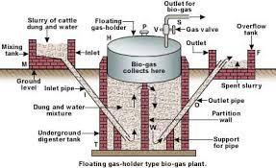

Fig.1.1 Floating type biogas plant

Biogas is generated when bacteria degrade biological material in the absence of oxygen; in a process known as anaerobic digestion. Since biogas is a mixture of methane (CH4), carbon dioxide (CO2), hydrogen sulphide and traces of water vapour. It is a renewable fuel produced from waste treatment. Anaerobic digestion is basically a simple process carried out in a number of steps by many different bacteria that can use almost any organic material as a substrate - it occurs in digestive systems, marshes, rubbish dumps, septic tanks and the Arctic Tundra. Biogas is a gas produced from organic materials such as animal manure, human excreta, kitchen remains, crops straws and leaves after decomposition.

**1.1 Project Background**

Solid Waste management is a process of treating biological waste and to produce liquid waste suitable for discharge to the environment or for reuse with some bi-products. The process of Biological treatment can be done either by aerobic fermentation or by anaerobic fermentation. Due to high running cost for aerobic treatment anaerobic treatment is usually promoted which can produce Biogas and manure which can be used as fertilizer. Biogas is produced by anaerobic digestion or fermentation of biodegradable materials such as biomass, manures, sewage, municipal waste, green waste, and plant material and energy crops. This type of biogas comprises primarily methane and carbon dioxide. Anaerobic digesters also function as a waste disposal system, even for human waste, and can, therefore, prevent potential sources of environmental contamination and the spread of pathogens. Industries and institutions are also made possible, from the sale of surplus gas to the provision of power for industry therefore, biogas may also provide the user with income generating opportunities. The true degree of effectiveness of biogas plants and consequently their profitability is in the maximum possible utilization of annual hours of full capacity use. Procurement of highest-quality components reduces downtime to a minimum. Profitable biogas plants provide additional yield from constant full capacity running with cost savings achieved from a low degree of downtime. In this way, it is possible to achieve a working life of 20 years or more with a biogas plant. The proposal for 50Kg solid bio waste treatment plant has been designed based on the biowaste characteristics provided by the client.

**1.2 Technical Note**

* The design temperature is 20-30°C.
* The process carried out is anaerobic digestion.
* The design has been prepared based on the Solid waste characteristics which are listed

in the design basis.

* The tank dimensions are subject to changes during the detailed engineering and layout

preparation. However the volume remains the same.

* The treated waste (Liquid Slurry) from the outlet shall be utilized mainly as fertilizer for

Plants or can be connected to drainage.

**Technical details of biogas**

* 1 cum Bio Gas is = 0.5 kg LPG (Approximate)
* 1 cum Bio Gas is = Firewood 3.5 kg
* 1 cum Bio Gas is = Cow dung cake 12.3 kg
* 1 cum Bio Gas is = Diesel 0.5 liter

**TECHNICAL DETAILS OF THE PROPOSED TREATMENT PLANT**

a) Design: Anaerobic Digester

b) Type: Vertical portable system

c) Capacity of Treatment Plant: 15 cum

d) Land required for the Plant: 2.5 $×$ 2.5 Sq. meters

e) Treatment Capacity per plant: 50kg solid waste

f) Gas production: 5 Kg LPG equivalent gas

**Specifications/Standards:**

1. Treatment Capacity - 50Kg of bio waste per day

2. Digester with fiber reinforced plastic for capacity up to 50Kg.

3. Inlet devices for latrine waste as well as food waste with PVC pipe 6” 6 Gauge

4. Rubber hose stove and control valve with ISI mark

5. Gas holder 4 layered fiber reinforced plastic

**Chemical Coating**

1. Polyester ISO Resin

2. Polyester ISO Resin Gel coat

3. Glass fiber mat 600E

4. G.I pipe with Gas holder B-CLASS 3” pipe.

Center support of GI pipe 4” B-Class (with FRP coating) fixed to base fixed to central

Beam.

**1.3 Technology**

Anaerobic fermentation is the technology used in this treatment plant. The anaerobic fermentation technology has been used for years for the production of biogas plant. The technology may be used for industrial as well as municipal wastewaters. Different models has-been developed by different countries on the basis of their requirement. The Synod bioscience

Adopt KVIC floating drum model which has been developed by Khadi and Village Industries

Commission and it’s an approved model of Ministry of New & Renewable Energy, Government

of India. The advantage of this model is its low construction cost, high efficiency and can be

There are a number of microorganisms that are involved in the process of anaerobic digestion

including acetic acid-forming bacteria and methane-forming methanogens. These organisms

feed upon the initial feedstock(cow dung and previous slurry), which undergoes a number of

different processes converting it to intermediate molecules including sugars, hydrogen, and

acetic acid, before finally being converted to biogas. Different species of bacteria are able to survive at different temperature ranges. Ones living optimally at temperatures between 35–40°C are called mesophiles or mesophilic bacteria. Some of the bacteria can survive at the hotter and more hostile conditions of 55–60°C, these are called thermophiles or thermophilic bacteria. Methanogens come from the domain of archaea. This family includes species that can grow in the hostile conditions of hydrothermal vents. These species are more resistant to heat and can therefore operate at high temperatures, a property that is unique to thermophiles.

As with aerobic systems the bacteria in anaerobic systems the growing and reproducing microorganisms within them require a source of elemental oxygen to survive. In an anaerobic system there is an absence of gaseous oxygen. Gaseous oxygen is prevented from entering the system through physical containment in sealed tanks. Anaerobes access oxygen from sources other than the surrounding air. The oxygen source for these microorganisms can be the organic material itself or alternatively may be supplied by inorganic oxides from within the input material. When the oxygen source in an anaerobic system is derived from the organic material itself, then the 'intermediate' end products are primarily alcohols, aldehydes, and organic acids plus carbon dioxide. In the presence of specialized methanogens, the intermediates are converted to the 'final' end products of methane, carbon dioxide with trace levels of hydrogen sulfide. In an anaerobic system the majority of the chemical energy contained within the starting material is released by methanogenic bacteria as methane. Populations of anaerobic microorganisms typically take a significant period of time to establish themselves to be fully effective. It is therefore common practice to introduce anaerobic microorganisms from materials with existing populations, a process known as "seeding" the digesters, and typically takes place with the addition of sewage sludge or cattle slurry.

Sugars

Hydrogen carbon dioxide ammonia

Carbonic acids and alcohols

Hydrogen acetic oxide carbon dioxide

Proteins

Fats

Carbohydrates

Fatty acids

Methane carbon dioxide

Amino acids

Hydrolysis Acidogenesis Acetogenesis Methanogenesis

Fig.1.3 Block diagram of biogas production system

The key process stages of anaerobic digestion There are four key biological and chemical stages of anaerobic digestion:

1. Hydrolysis

2. Acidogenesis

3. Acetogenesis

4. Methanogenesis

In most cases biomass is made up of large organic polymers. In order for the bacteria in anaerobic digesters to access the energy potential of the material, these chains must first be broken down into their smaller constituent parts. These constituent parts or monomers such as sugars are readily available by other bacteria. The process of breaking these chains and dissolving the smaller molecules into solution is called hydrolysis. Therefore hydrolysis of these

high molecular weight polymeric components is the necessary first step in anaerobic digestion. Through hydrolysis the complex organic molecules are broken down into simple sugars, amino acids, and fatty acids. Acetate and hydrogen produced in the first stages can be used directly by methanogens. Other molecules such as volatile fatty acids (VFA’s) with a chain length that is greater than acetatemust first be catabolised into compounds that can be directly utilized by methanogens.The biological process of acidogenesis is where there is further breakdown of the remaining components by acidogenic (fermentative) bacteria. Here VFAs are created along with ammonia, carbon dioxide and hydrogen sulfide as well as other by-products. The process of acidogenesisis similar to the way that milk sours. The third stage anaerobic digestion is acetogenesis. Here simple molecules created through the acidogenesis phase are further digested by acetogens to produce largely acetic acid as well as carbon dioxide and hydrogen. The terminal stage of anaerobic digestion is the biological process of methanogenesis. Here methanogens utilize the intermediate products of the preceding stages and convert them into methane, carbon dioxide and water. It is these components that makes up the majority of the biogas emitted from the system. Methanogenesis is sensitive to both high and low PHS and occurs between pH 6.5 and pH 8. The remaining, non-digestible material which the microbes cannot feed upon, along with any dead bacterial remains constitutes the dig estate.

**Typical composition of bio gas**

|  |  |
| --- | --- |
| **Constituent gases** | **Percentage (%)** |
| Methane,CH4 | 50-75 |
| Carbon dioxide,CO2 | 25-50 |
| Nitrogen,N2 | 0-10 |
| Hydrogen,H2 | 0-1 |
| Hydrogen sulfide,H2 S | 0-3 |
| Oxygen,O2 | 0-2 |

Table 1 Typical composition of bio gas

**1.4 Process Description**

The proposed system consists of following stages:

**Feeding at the Inlet tank**

Inlet tank is connected to the digester. The feeding process is carried out through inlet.

This feed directly enters to the digester where the anaerobic digestion takes place.

**Main Digester**

The size of this digester will be 2.1m×1.8m and will be fabricated FRP. The RCC has a volume of 100 cum digester volume .The RCC digester will be completely underground structure which can absorb more heat from earth and also enhance the gas production due to the same. The

Plant will be water jacketed system which prevents foul smell and makes the plant 100% hygienic from the environment. The digester design is made with two compartments, first one is Solid chamber where the solid retain for a particular retention time and it pass to the liquid Chamber where these solid will be 80% digested and further digestion take place there. After Liquid chamber digestion the slurry will be passed to the outlet. Digester also has a central Guide of MS made with 7.5 cm diameter which will hold the gas holder in position

**Gas Holder**

As the part of digestion methane gas will be formed which will be collected in the gas holder. Gas holder is made up of 12 gauge GI sheet with 3.8 cm anglier reinforcement. It will be supported by 10 cm MS pipe central guide system which holds the gas holder in position. The outer gas holder is coated completely with two layers of FRP lining 600 E fiber matt and with ISO resin which prevents corrosion due to rain and sunlight. Inner side of digester is coated with

ISO gel coat which prevent corrosion due to H2S and water FRP. Gas holder itself weigh a weight of 1 -1.5 ton approx. which is the driving force for pumping gas directly to the kitchen without any pumping system. Gas holder itself has an automatic pressure system which removes the excess gas to atmosphere if the pressure exceeds 14 – 16 cm rise in water column. This excess gas can be lighted with the help of flaring unit. Gas holder also has a mixer which is connected with the gas holder which prevents scum formation and helps in better gas production.

**Slurry pumping at the Outlet tank**

Digester is connected to an outlet tank in which slurry can be collected. This slurry can be

directly used as fertilizer or can be connected to drainage. It’s an odorless blackish water

with organic value of NPK 1:0.5:0.5

**Burners**

This gas will be connected with biogas burners which is situated in the kitchen. Plumping

connection will be given for 3-4 stoves depending up on the distance and pressure. Pipe

Connection will be taken through upvc/pvc.

**Moisture trap**

Biogas contains trace quantity of water vapor. So this vapor will get condenser and block the flow of gas. So in order to remove the water, water trap will be placed in regular intervals.

Biogas plant height: 10 feet

Biogas plant area required: 2.4×2.4 Sq. meter

Quantity of cow dung required at the time of installation: 1 truck of cow dung

**CHAPTER 2**

**LITERATURE REVIEW**

This chapter deals with the research work already carried out in the field of biogas production and its applications.

**N.H.S.Ray, R.C.Mohanty, M.K.Mohanty [1]:** Biogas derived from organic wastes is considered as good alternative to petroleum fuels. Fuels can be a supplemented to liquefied petroleum gas (LPG) and compressed natural gas (CNG), if it is used in compressed form in cylinders. This study reviews the current status and perspectives of biogas production, its’ up gradation through purification & storage methods and its engine applications. Here through detailed literature review, the combustion characteristics of biogas in compression ignition engines are investigated.

**BekeleGaddisa [2]:** Based on present energy consumption, biogas fulfills the cooking energy requirement for 43 households. If households use biogas instead of kerosene only, it can serve the cooking energy need for 115 households. The Compressing biogas reduces storage requirements, concentrates energy content and increases pressure to the level needed to overcome resistance to gas flow. As the result of installing compressor for this system, 343.2 m3 of biogas volume is stored in 37m3 of pressure vessel and the pressure increased to 11bar from 1.106 bar.

**N.H.S.Ray, P.R.Swain, M.K.Mohanty, R.C.Mohanty [3]:** This paper presents the developments in biogas purification and storage into LPG cylinders for easy and cost effective utilization. The paper also presents water scrubbing as a better option for biogas purification. Compression of biogas was carried out by using a reciprocating type compressor and bottled into normal LPG cylinder. Boiling test was conducted whereby the combustibility of the compressed biogas from the cylinder in normal biogas-stove to validate its use in cooking.

**BabuelamOchieng’ J. O. Agullo [4]:** Purification and Compression of Biogas which is an experimental report on using hermetic reciprocating refrigerant compressor and the compressed biogas used in a stove for cooking purpose. The biogas compression was carried out under isothermal and adiabatic compression up to 11 bar absolute pressure. Biogas compressor project, which is done to make a hand operated biogas compressor to compress biogas by hand pumping and stored in compressed air tanks. In this project that biogas was compressed into a cylinder and used to drive a car. The biogas was compressed to 20 MPa pressure using a three stage compressor after moisture removal and filled in special high pressure steel cylinders and then tested in a vehicle that managed to run 55.1 km in 1hour 25 minutes.

**David Giard [5]:** In-Storage-Psychrophilic-Anaerobic-Digestion (ISPAD) is a technology which allows livestock producers to operate an anaerobic digester with minimum technological and for the cost of a conventional storage cover. The objective of the present project was therefore to design an automated biogas composition monitoring system for ISPAD and analyze the biogas composition produced during the time span of the project.

**Jancebula [6]:** A number of research centers are interested in uncontrolled release of methane into the atmosphere. The production of bio methane from bio-gas offers the possibility of acquiring chemical resources, fuel for combustion engines, gas turbines and fuel cells. However, each biomethane application facilitates specific treatment. The study shows methods of biogas treatment which ensure its purity so that it could be used as engine fuel, network gas, CNG and in fuel cell. It also demonstrates absorption techniques of biogas treatment described in the literature and results of the author’s research.

**Dr. Mike Clifford [7]:** Researchers aimed to create a system to create a system to compress and store biogas in a manner appropriate to rural communities in the developing world. Research indicated that a manually actuated, single-acting compressor, capable of reducing the volume by a factor of 3 – 4, would be an appropriate solution.

**P E Willey, J E Campbell [8]:** This review paper identifies and describes various technologies available for each steps of purification. A possible solution would be to compressing biogas into cylinders, thereby making it transportable and must be removed using scrubber systems to make bio gas compression economical

After reviewing the above research papers the problem statements and objectives are formed.

**CHAPTER 3**

**PROBLEM STATEMENT AND OBJECTIVE**

**3.1. Problem Statement**

* Raw biogas is utilizing at the same flow rate it produced because of insufficient storing.
* Raw biogas thus produced is using directly for building heating, cooking etc. without purification which has low calorific value.
* The storage of raw biogas requires big cylinder for small quantity of methane because of the presence of CO2, H2S, etc.
* The usage biogas requires limited distance between production and utilizing points due to pipe connection.

|  |  |
| --- | --- |
| **Constituents** | **Percentage (%)** |
| Methane[ CH4] | 50 - 60 |
| Carbon Dioxide[ CO2 ] | 34 - 38 |
| Oxygen[ O2 ] | 0 - 1 |
| Hydrogen Sulphide | Trace |

Table 2 Biogas constituents

**3.2. Objective**

* To purify the raw biogas obtained from waste organic resources.
* To remove the impurities like CO2, H2S, O2, N2 and moisture content present in the raw biogas for easy compression and storage in small cylinder.
* To store biogas for transporting over long distance wherever it is required.

**CHAPTER 4**

**METHODOLOGY AND EXPERIMENTAL SET UP**

**4.1 Method of bio gas production**

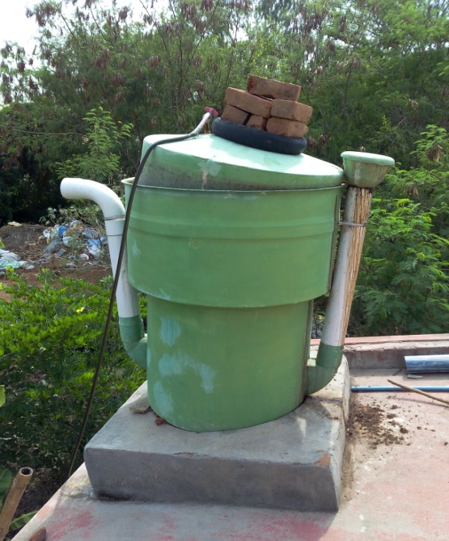

Fig 4.1 Bio gas production

A typical biogas system consists of the following components:

(1) Manure collection

(2) Anaerobic digester

(3) Effluent storage

(4) Gas handling

(5) Gas use.

Biogas is a renewable form of energy. Methanogens (methane producing bacteria) are last link in

a chain of microorganisms which degrade organic material and returns product of decomposition

to the environment.

**Principles for Production of Biogas**

Organic substances exist in wide variety from living beings to dead organisms. Organic matters are composed of Carbon (C), combined with elements such as Hydrogen (H), Oxygen (O), Nitrogen (N), Sulphur (S) to form variety of organic compounds such as carbohydrates, proteins & lipids. In nature MOs (microorganisms), through digestion process breaks the complex carbon into smaller substances.

There are 2 types of digestion process:

1. Aerobic digestion.

2. Anaerobic digestion.

The digestion process occurring in presence of Oxygenis called Aerobic digestion and produces mixtures of gases having carbon dioxide (CO2), one of the main “green houses” responsible for global warming.

The digestion process occurring without oxygenis called Anaerobic digestion which generates mixtures of gases. The gas produced which is mainly methane produces 5200-5800 KJ/m3 which when burned at normal room temperature and presents a viable environmentally friendly energy source to replace fossil fuels (non-renewable).

The procedures followed in this experiment involves: Designing and establishing of biogas purification, compression and bottling unit and Executing different tests, namely - amount of carbon dioxide in the biogas test, water acidity test and water boiling test. Due to unavailability of standard measuring instruments (Gas Analyzer) required to   
verifying the results, experiments were limited and improvements were made through trial and error, i.e. only by the evaluation of amount of CO2 available in the gas.

**4.2 Designed and establishment of biogas scrubbing and storage facility**

The designed biogas scrubbing and storage facility is composed of two units, namely, the scrubbing unit and the storage unit. The entire biogas scrubbing and storage facility is schematically represented in Fig

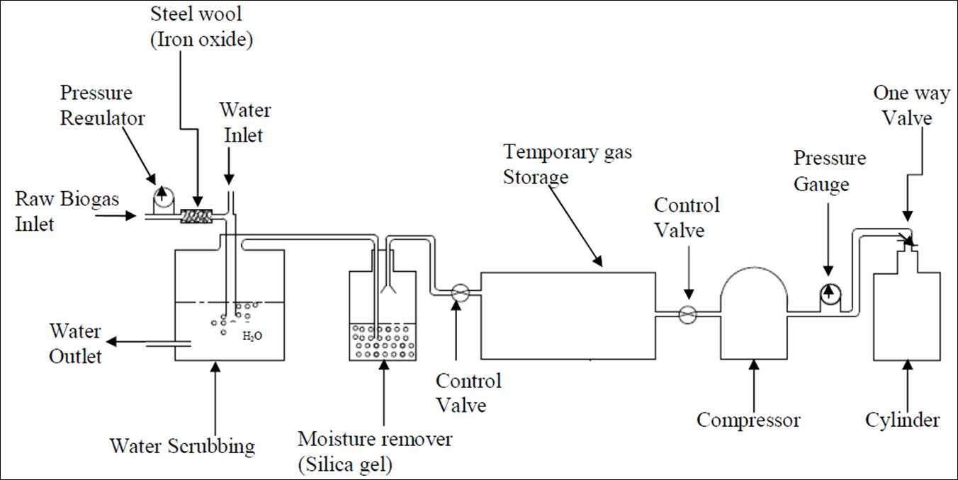

Fig 4.2 Designed and establishment of biogas scrubbing and storage facility

**4.2.1. Biogas Scrubbing**

The biogas scrubbing system consists of three units, the hydrogen sulfide (H2S) removing unit, Carbon dioxide (CO2) removing unit, and moisture trapping unit. The three units are interconnected with plastic hoses. In the purification process of biogas which was conducted; steel wool, pure water and an adsorbent material (silica gel) were used. The steel wool is to react with the hydrogen sulphide, the water is to reduce the percentage of carbon dioxide and the silica gel is to reduce the presence of water vapour in the purified biogas. The experiment was done by taking the raw biogas with pressure builds up in the digester head and forced through the steel wool on its way to the biogas scrubber unit to remove hydrogen sulphide. After the hydrogen sulphide was removed by the steel wool, the raw biogas passes into the water scrubbing unit for further purification. When carbon dioxide dissolved in water carbonic acid (H2CO3) is formed. It is a weak acid.

H2O + CO2 ---> H2CO3

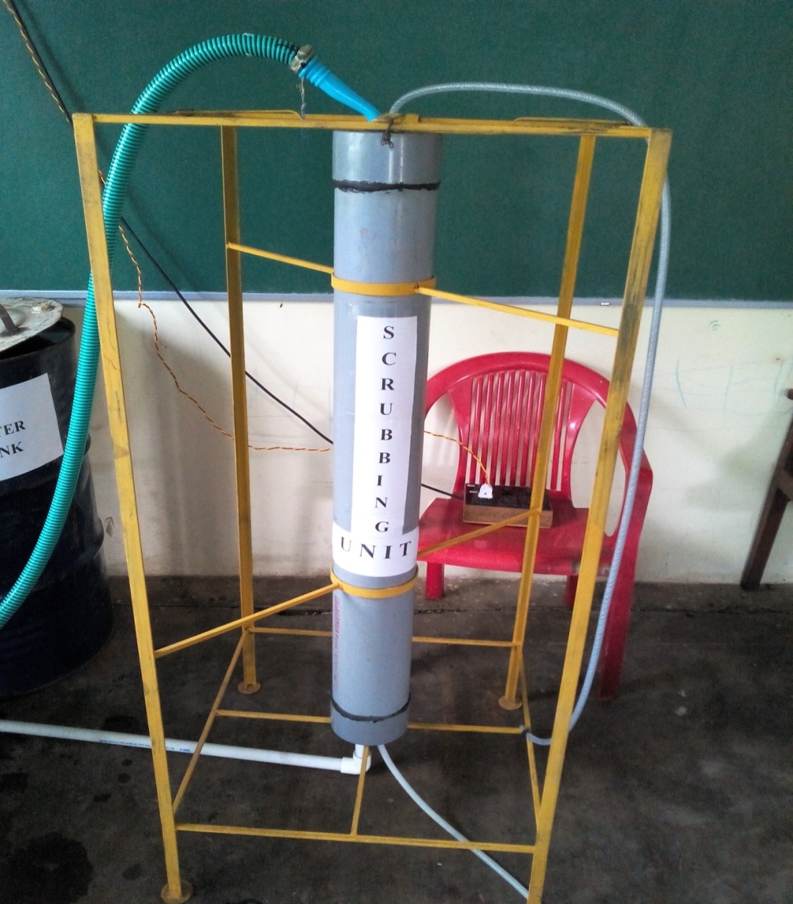

Fig 4.2.1 Biogas scrubbing process

The liquid leaving the scrubbing unit will thus contain increased concentration of carbon dioxide, while the gas leaving the scrubbing unit will have an increased concentration of methane. The purified biogas that was collected at the top of the scrubber unit has some water vapours. Water vapour is the leading corrosion risk factor. To reach water contents as low as in the purified biogas, silica gel was used in this experimental set up. Silica gel is a material that has

a capability of absorbing moisture.

The experiment presents development of biogas scrubbing and bottling system to substitute compressed natural gas used in cooking, automobile and transport applications. A biogas plant, CO2 scrubbing and bottling technology has been designed and developed at PES College of Engineering Mandya, Karnataka. India based on physical absorption of CO2 in water at elevated pressure. The developed scrubbing system is able to remove CO2 from raw biogas when pressurized raw biogas was fed into the packed bed scrubbing column and pressurized water is sprayed from top in counter-current action. After the scrubbing clean pressurized gas leaves the column and stored. After upgrading the biogas is to be dried by using a container filled with silica gel to remove moisture. Then it is to be stored in LPG cylinder for cooking application.

**4.3 Process Descriptions**

A typical and simplified design of a biogas upgrading unit is shown above. The raw biogas is usually allowed to have a temperature up to 40 ºC when it arrives to the upgrading plant. The

Pressure of the raw biogas is increased to around 6-10 bar before it enters the absorption column. By increasing the pressure and lowering the temperature (to the temperature of the water in the scrubber), most of the water in the biogas is condensed and separated from the gas before it enters the absorption column. If the raw biogas is saturated with water at 40 ºC when it enters the

upgrading unit, only around 5% of the water content will remain in the gas phase if the pressure is increased to 6 bar and the temperature is lowered to 15 ºC.

The pressurized biogas is injected into the bottom of the absorption column and water is injected to the top of the column. It is important that the water and the gas have a counter flow to minimize the energy consumption as well as the methane loss. The water leaving the absorption column has been equilibrated with the highest partial pressure of carbon dioxide and the lowest partial pressure of methane. This results in that the water contains as much carbon dioxide as possible and as little methane as possible. The absorption column is filled with packing to increase the contact surface between the water and the biogas to make sure that the carbon dioxide is absorbed as efficiently as possible in the water. The height of the bed and the type of packing determines the efficiency of separation in the column, whereas the diameter determines the gas throughput capacity. Thus, a higher bed can clean biogas with lower incoming methane concentration and a wider column can treat a larger volume of biogas. It is also important to know that the diameter does not only increase the maximum capacity but also the minimum raw gas flow that is possible to treat. If the load is too low, the water will not be evenly distributed over the cross section area and the biogas will be mixed with the water in a suboptimal way.

The pressure in the flash column has to be decreased to maintain the same methane slip if the methane concentration in the raw biogas increases. The reason is that more methane and less carbon dioxide are transported with the water into the flash column, resulting in a changed composition more CH4 and less CO2 in the flash column gas volume. If the pressure is kept constant, the partial pressure of methane will increase significantly resulting in higher solubility in the water. For a system working at 8Bar, the flash pressure has to be decreased from about 3 bar to about 2Bar when the methane concentration is increased from 50% to 80% in the incoming raw biogas. The flash column has no packing and is designed with a diameter wide enough to decrease the vertical speed of the water to such an extent that even small gas bubbles are able to rise instead of being dragged into the desorption column.

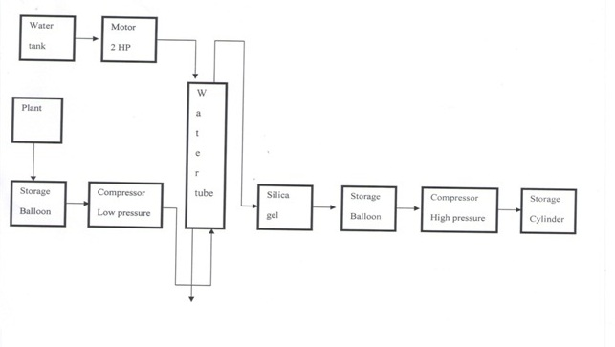

Fig.4.3 Block diagram of biogas compression and storage system

**4.4 Water Scrubber**

Water scrubbing involves the physical absorption of CO2 and H2S in water. It is a simple method involving use of pressurized water as an absorbent. The raw biogas is compressed and fed into a packed bed absorption column from bottom and pressurized water is sprayed from top. The absorption process is, thus a countercurrent one. This dissolves CO2 as well as H2S in water, which are collected at the bottom of the tower.

In this process the biogas is cleaned from CO2, H2S and NH3 that are physically dissolved in water under pressure in an absorption column. CH4 is also dissolved in water, but its solubility is lower than the other substances. Solubility increases with increasing pressure and decreasing temperature. There are two types of water absorption process single pass absorption and regenerative absorption. In both processes biogas is introduced from the bottom of a tall vertical column and water is fed at the top of the column to achieve a gas-liquid counter flow. The column is equipped with packing to give a large specific surface for gas-liquid contact. The concentration of CO2 decreases during flow and the gas becomes more and more concentrated with methane. The upgraded biogas leaves the column at the top.

**System Design**

A packed bed scrubber was designed for 95 % removal of carbon dioxide from biogas. Thus, initially 40 % carbon dioxide present in raw biogas would be reduced to 2 % by volume in enriched biogas. To increase solubility of carbon dioxide in water, raw biogas was compressed up to 12bar pressure and pressurized water was used as an absorbent liquid.

**4.5 Biogas Compression and Storage**

The biogas storage system consists of three units; a compressor, a pressure gauge and an LPG cylinder. The compressor used in the experiment is a hermetic reciprocating type compressor used in the manufacture of commercial refrigerators with a hydrocarbon refrigerant. The pressure of the gas at various points of compression can be noted using a pressure gauge. For storing the gas after compression, a normal LPG cylinder was used.

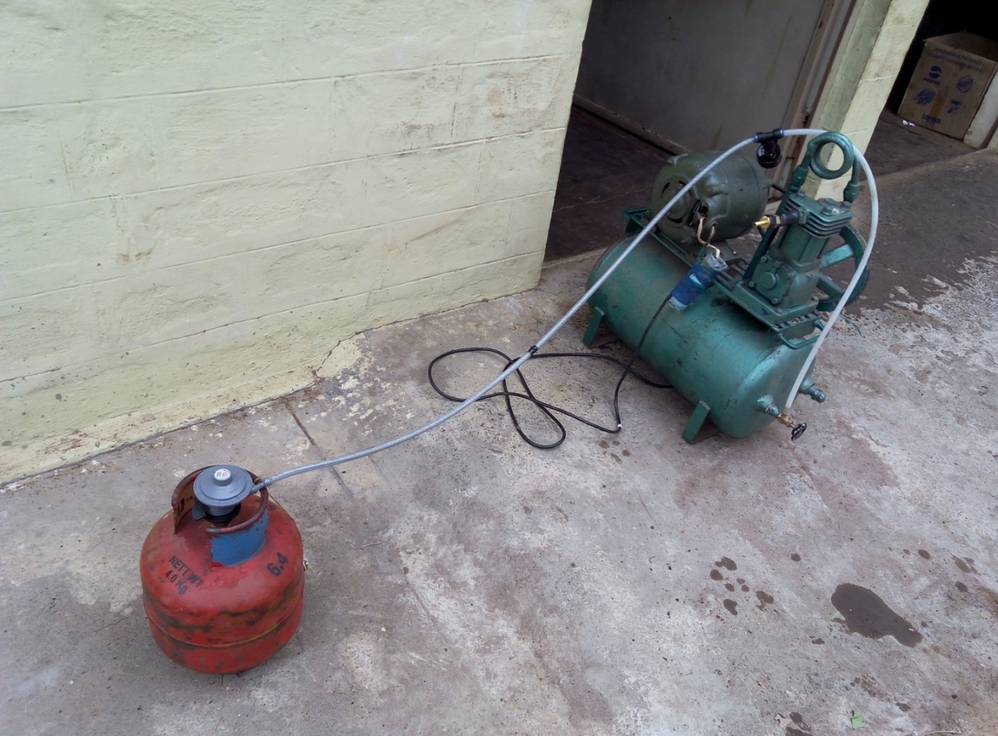

Fig 4.5 Biogas Compression and Storage (Bottling)

**4.6 Material Collections**

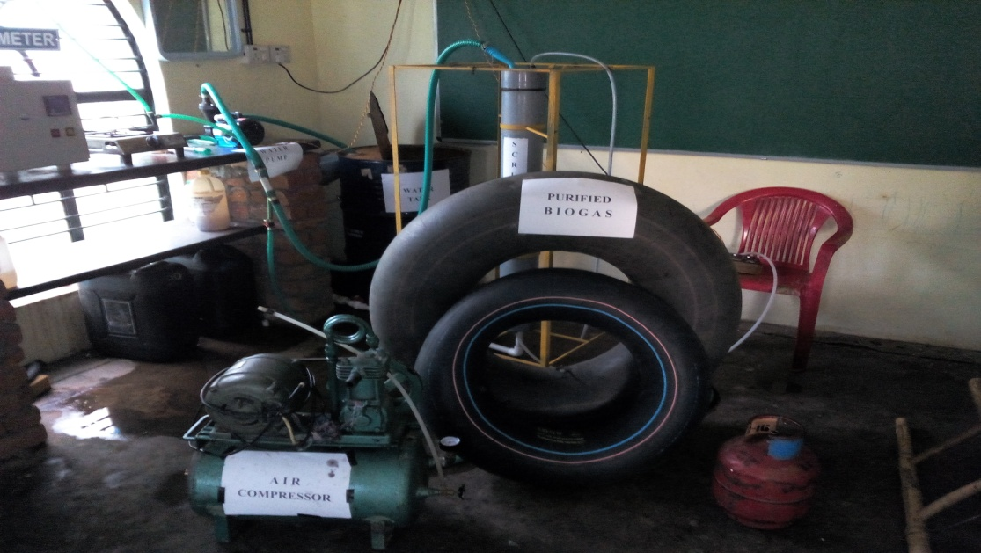

Fig.4.6 Experimental setup

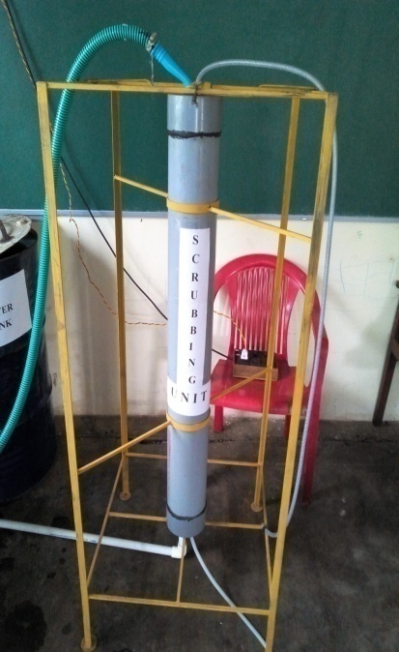**4.6.1. Bio Gas scrubbing unit:**

Biogas scrubbing unit is mainly used to purify the raw biogas by removing CO2, H2S and other impurities present in the raw biogas.

**Specifications:**

Height of the unit: 5 feet

Width of the unit: 2 feet

Length of the pipe: 5feet

Diameter of the pipe: 5 inch

Fig.4.6.1 Biogas scrubbing unit

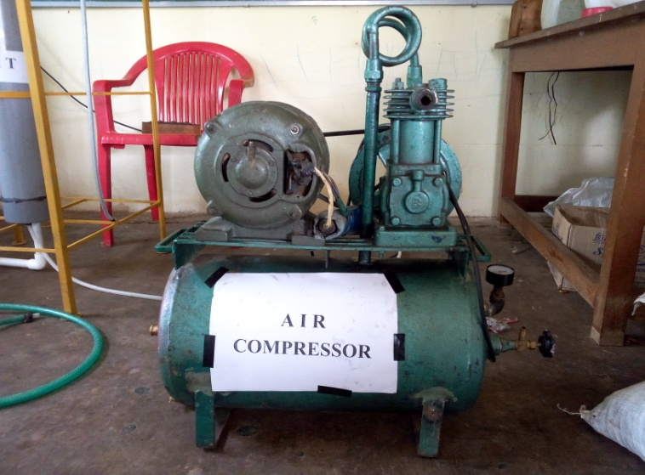

**4.6.2. Air Compressor:**

**Specifications:**

Maximum pressure: 10 Bar or 150 PSI

Running speed: 500rpm

Power: 1HP or 0.75KW

Air receiver: 70 liters

Fig.4.6.2 Air compressor

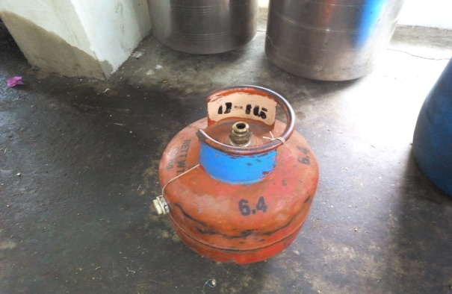**4.6.3 LPG Cylinder:**

**Specifications:**

Empty cylinder weight: 6.4KG

Thickness: 2mm

Height: 314mm

Maximum pressure: 2.1Mpa

Fig.4.6.3.LPGCylinder

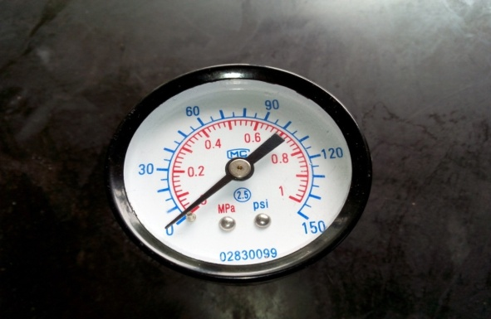

**4.6.4 Pressure gauge:**

**Specifications:**

Maximum pressure: 10Bar

Operating temperature: –40 to 60°C

Material: stainless steel

Fig.4.6.4Pressure gauge

**4.6.5 Pipe fittings (PVC) and Valves:**

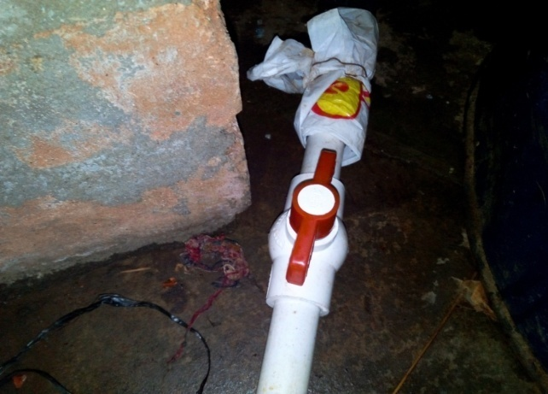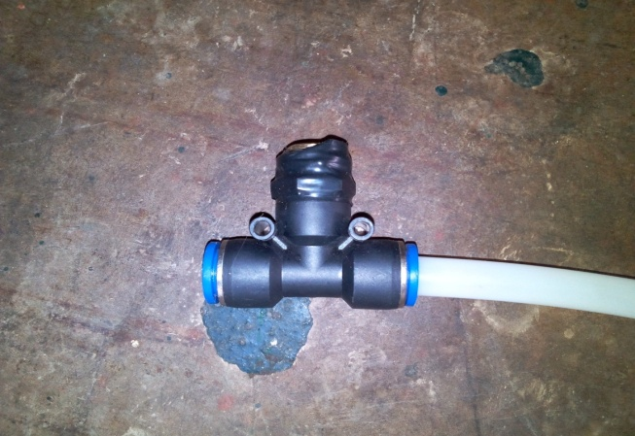Fig.4.6.5 Pipe fittings (PVC) and Valves

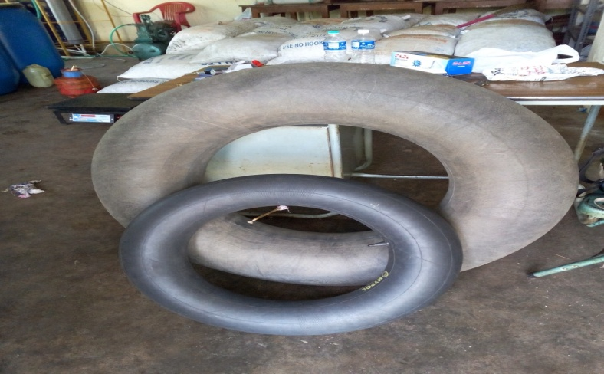

**4.6.6 Biogas storage tube:**

**Specifications:**

Material: High quality rubber

Fig.4.6.6 Biogas storage tube

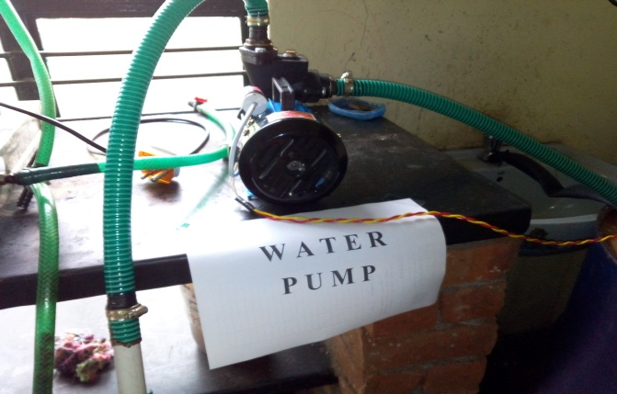

**4.6.7 Water pump:**

**Specifications:**

Power: 0.5HP or 0.37KW

Pipe size: 25mm

Maximum flow: 90 LPM

Maximum Working pressure: 4 bar

Liquid temperature: +60°C

Fig.4.6.7 Water pump

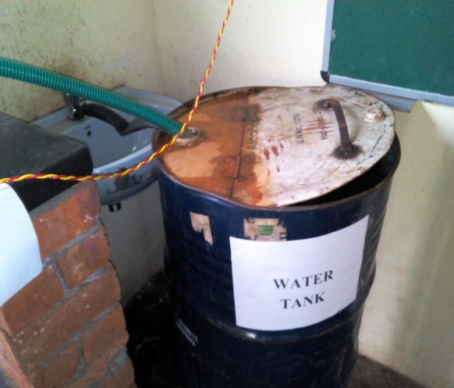

**4.6.8. Water tank:**

**Specifications:**

Capacity: 250 Liters

Material: mild steel

Fig.4.6.8 water tank

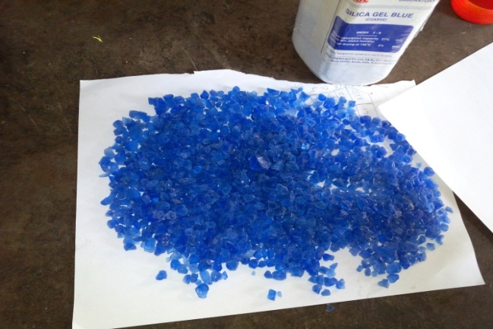

**4.6.9. Silica gel:**

Silica gel is used to absorb the moisture

content present in the purified biogas.

**Specifications:**

[Chemical formula](http://en.wikipedia.org/wiki/Chemical_formula): SiO2

Molar mass: 60.08 g/mol

Odor: odorless

Fig.4.6.9 silica gel



**4.6.10. Steel wool**

Steel wool is also known as wire wool or wire sponge. It is used to absorb the H2S content present in the biogas.

Fig.4.6.10 steel wool

**CHAPTER 5**

**RESULTS AND DISCUSSIONS**

**Performance of Water Scrubbing System on Removal of CO2 from Biogas:**

Percentage absorption of carbon dioxide in water was determined in terms of variation in inlet gas flow rates and inlet gas pressures. The scrubber was designed for 95 % CO2 absorption from raw biogas in pressurized water for 2 m3/h inlet gas flow rate at 6 bar gas pressure. Accordingly, the variation in inlet gas flow rates from 1.0 - 2.0 m3/h were studied at 3 bar gas pressure. The values of methane content observed were 77.66, 79.00, 73.96 % at 1.0, 1.5, 2 m3/h gas flow rates respectively.

It was found that the percentage CO2 absorption from raw biogas has initially increased when gas flow rate vary from 1.0 to 1.5 m3/h and afterwards it decreased continuously. The highest CO2 absorption (90%) was observed at 1.5 m3/h gas flow rate at 2 bar inlet gas pressure. The best performance of the scrubber was found at 1.5 m3/h gas flow for maximum CO2 absorption at 1.8 m3/h wash water flow rate. The scrubber works perfectly well around 1.8 m3/h wash water flow rate, above this flow rate, flooding starts.

**Biogas bottling:**

The purified biogas is filled into the cylinder at 5 bar pressure. The capacity of cylinder is 4 Kg that is, it can store 4 Kg of LPG. However it can able to store only 1 Kg of biogas in it because LPG was compressed up to 270 times that of its initial volume. Additional to this, the specific volume of biogas is lower than that of LPG. The quantity of biogas filled into the 4 Kg is 0.5 Kg at 5 bar pressure. Multi stage compressor or refrigeration compressor is necessary for bottling of biogas in order to fill sufficient quantity of biogas into cylinder. In this case, there is successive removal of heat from compressing biogas at constant pressure. This increases the quantity biogas to be stored. Single stage compressor can also be used but it will not store required quantity due to condensation problems. Apart from it, as the pressure increases temperature will also increase, which avoids the usage of single stage compressor for biogas storing in cylinders.

**CHAPTER 6**

**COST ANALYSIS**

|  |  |  |
| --- | --- | --- |
| **Sl no** | **Components** | **Cost (INR)** |
| 1 | Bio Gas scrubbing unit | 3600 |
| 2 | Air Compressor | 6000 |
| 3 | LPG Cylinder and regulator | 1050 |
| 4 | Pressure gauges | 400 |
| 5 | Pipe fittings(PVC) and Valves | 2300 |
| 6 | Storage tube | 600 |
| 7 | Water pump | 1500 |
| 8 | Silica gel | 300 |
| 9 | Water tank | 250 |
| 10 | Transportation cost | 4000 |
| 11 | Labour cost | 2000 |
|  | **Total cost** | **22000** |

Table 3 Cost analysis

**CHAPTER 7**

**APLICATIONS OF BIOGAS**

The compressed and stored biogas in cylinders can be used for various purposes. The main application of stored biogas is to generate electricity which will help in bridging the supply and demand gap. It can also replace household LPG useful for cooking purposes. CNG cylinders can be replaced by BIO CNG cylinders which will act as an environmental friendly fuel. This will help in achieving carbon credits.

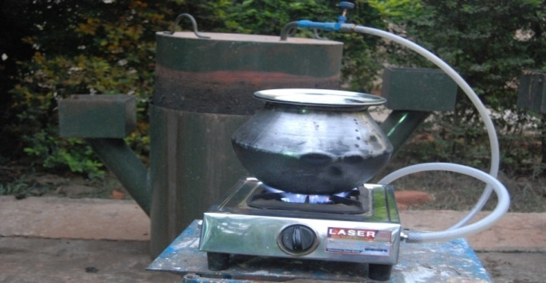 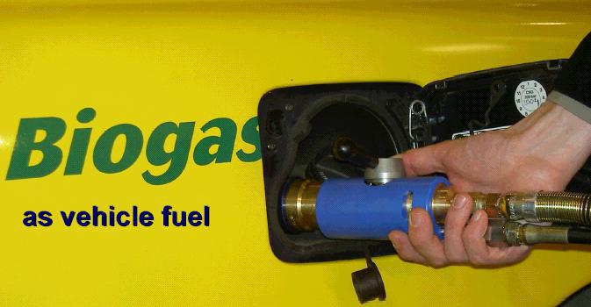

Fig.7.1 cooking purpose Fig.7.2 Transportation

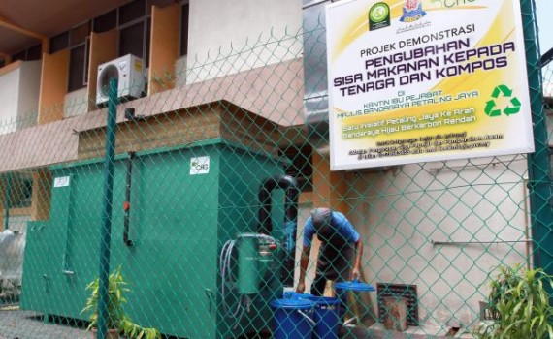

Fig.7.3 Power generator

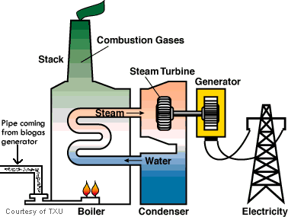

Fig.7.4 Electric Power plant

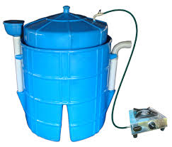

Fig.7.5 Mini biogas plant for cooking purpose



Fig.7.6 Biogas plant for home appliances

**CHAPTER 8**

**CONCLUSIONS**

There is large potential of biogas generation to make it an alternate fuel for vehicle and as cooking gas. Biogas produced from the digester should be enriched before bottling, as enriched biogas has more calorific value and better fuel quality. Out of several methods of biogas enrichment, water scrubbing is found to be a simple, low-cost and suitable method for enrichment of biogas in rural areas. The designed and fabricated biogas scrubber is able to remove 95% of carbon dioxide present in raw biogas. To make biogas suitable for cooking application, the enriched biogas was compressed up to 6 bar after moisture removal and filled in LPG cylinders. Overall, the study revealed that biogas production, enrichment and compression system is a profitable venture for the areas where large quantity kitchen wastes are available. The system is recommended to establish rural entrepreneurship for the effective utilization of local biomass resources for production of biogas energy in decentralized manner and sustainable rural development. Gas compressors and water pump are the main reasons for the electricity demand. Optimization of flow rates and temperatures are thus important tasks for the efficient operation of the upgrading units. Small scale upgrading is also an interesting topic, but will most likely not become too common due to the high specific investment costs for small upgrading plants.

* Scrubbing unit and all the set up and fittings are to designed in metals.
* Multi stage cylinder is necessity for storage of biogas into cylinder over the usage of single stage cylinder in medium and large scale production.
* There is a vast potential for the production of biogas in our country. In addition to the energy production, biogas plants also provide bio-manure and are helpful in dealing with the problems of waste management, providing clean environment and mitigating pollution in urban, industrial and rural areas.
* The system is recommended to establish rural entrepreneurship for the effective utilization of local biomass resources for production of biogas energy in decentralized manner and sustainable rural development.
* Biogas produced in large size biogas plants should be upgraded before bottling for storage and mobile purpose, as upgraded biogas has more calorific value than raw biogas. Biogas is also a prominent alternative to petroleum fuel like LPG, CNG and diesel.
* Biogas is no more just the renewable energy source of rural population but it is also an abundant and appropriate source of energy for urban population, having potential to replace fossil fuel. Hence research and proper interest must be given towards advanced use of biogas.
* A detailed economic analysis including the cost of biogas plant installation and production of biogas must be carried out with the consideration of water scrubbing system for the removal of CO2 and H2S gas.

**CHAPTER 9**

**SCOPE OF FUTURE WORK**

The following points can be consider for the future work

* To withstand high pressure and for air tight, metallic scrubbing unit and pipe fittings are recommended for medium and large scale production.
* The biogas can be enriched above 95% of methane content by using suitable control over flow rate pressure at inlet and outlets of biogas in scrubbing unit.
* Multi stage compressor or refrigeration compressor is necessary for bottling of biogas in order to fill sufficient quantity of biogas into cylinder even single stage
* The LPG was compressed up to 270 times that of its initial volume before it is filled into the cylinder. It is possible to fill more amount of biogas by compressing it to greater value by using suitable condenser

**REFERENCES**

1. N.H.S.Ray, R.C.Mohanty, M.K. Mohanty “*Purification Technologies for Biogas Generated by Anaerobic Digestion*”, Climate Friendly Farming -CSANR Research Report 2010, Vol.1.
2. Bekele Gaddisa, “*Biogas Production System Design for Condominium and its Feasibility*”, Addis Ababa University, Ethiopia, November, 2011
3. N.H.S.Ray, P.R Swain, M.K. Mohanty, R.C.Mohanty, “*Study on Application of Biogas as Fuel in Compression Ignition Engines*”, International Journal of Innovations in Engineering and Technology (IJIET) Vol. 3, A
4. Babuelam Ochieng, “*Study of Biogas Production and Storage*”, Department of Environmental and Bio-systems Engineering, J. O. Agullo University of Nairobi, Vol. 2.
5. David Giard, “*Agricultural and low Pressure Separation Technique of Biogas into CH4 and CO2 employing PDMS membrane*”, Environmental Sciences Macdonald Campus of McGill University Ste-Anne-de-Bellevue, Québec, Canada.
6. Jancebula, “*Bio gas Purification Technique*”, Architecture civil Engineering, The Silesian University of technology, No. 2/2009.
7. Dr. Mike Clifford, “*A Study on Application of Biogas as Fuel in Compression Ignition Engines*”, International Journal of Advanced Engineering Technology, Vol. 3.
8. P E Willey, JE Campbel, “*Water Environment and Renewable Energy Resource”*, International Journals of Innovations in Engineering and Technology, Vol. 5.
9. Brian Herringshaw, “*A Study of Biogas Utilization Efficiency Highlighting Internal Combustion Electrical Generator units”*, College of Food, Agricultural, and Biological Engineering, The Ohio State University 2009.